JENNY & TYLER RELEASE HOLIDAY ALBUM "CHRISTMAS STORIES"
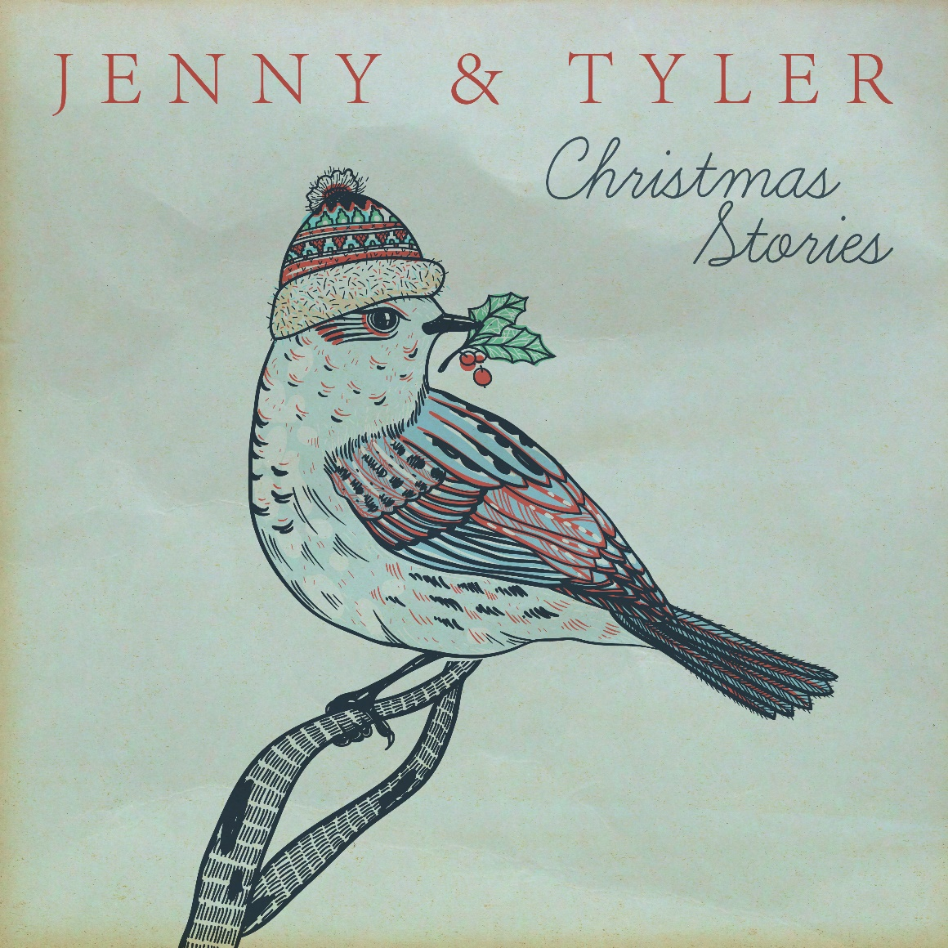

Nashville, Tenn. ---- Married folk-pop duo, Jenny & Tyler, release a new holiday album, Christmas Stories, on Nov. 4, 2016. Produced by Ben Shive (Colony House, Dave Barnes, Andrew Peterson,), the project features eight Christmas classics and one original song written by Jenny, Tyler, and Trent Monk, “Christmastime,” which is the single added to dozens of stations, including Air 1 Network, SOS Network, and K-Love Network. Christmas Stories marks the first time the duo worked with Shive, and the end result is a jazz sound with a nostalgic feel reminiscent of Bing Crosby, Simon and Garfunkel, and The Swell Season. The record is being released by Centricity’s new indie label, Residence Music, and will be distributed by Capitol Christian Distribution.

“Christmas Stories is our attempt to rekindle the wonder of Christmas,” explains Jenny. “It’s how we felt when we were kids waiting impatiently for Santa, reliving the Christmas story, and listening to our parents’ holiday albums.”
Adds Tyler, ‘The older you get, the more difficult it seems to be truly amazed by something. We recorded this album to give ourselves a reason to pause and reflect, to get back to that childlike wonder.”
Christmas Stories offers the listener the warmth of past Christmas’s and can be enjoyed while decorating your tree, looking at Christmas lights or drinking a hot cup of cocoa with family and friends. Such traditional favorites as “I’ll Be Home For Christmas,” “Handel’s Messiah,” and “White Christmas,” deliver the familiarity of well-loved songs, while the performances of Jenny & Tyler add their own unique contributions. With “Oh Holy Night,” Jenny imagined singing the classic as a lullaby for her two young daughters, while Tyler delivered an snappy, joyful version of “Winter Wonderland.” The couple’s fans also played a part in the song selection by suggesting “The Maker of the Sun and Moon.”

For additional information about Jenny & Tyler please visit online, www.jennyandtyler.com, www.facebook.com/jennyandtyler; www.twitter.com/jennyandtyler.

ABOUT
Jenny & Tyler are a married folk-pop act originally hailing from the east coast, first meeting on a bus on the campus of the University of Delaware. Both of them grew up in musical families with different tastes; Jenny grew up listening to bluegrass artists like Ricky Skaggs and while Tyler was hearing the tunes of artists ranging from Bing Crosby to James Taylor. Following their marriage in 2007, the couple began their artist career, performing and recording their own compositions and moving to Nashville a year later.
Even though Jenny & Tyler had diverse music styles between them, their coming together led to a unique sound of their own that began resonating with music fans. Drawing influence from Simon & Garfunkel, Glen Hansard, and Alison Krauss, Jenny & Tyler have found their place in today’s landscape of singers/songwriters in the folk-pop genre. Their songs have been featured on ABC’s Pretty Little Liars, NY Med, MTV’s Teen Mom, and YouTube’s Kid President. During the past ten years of mastering their craft, Jenny & Tyler have performed over 1,100 concerts nationally and internationally, developing their sound through extensive touring alongside such artists as Sara Groves, Green River Ordinance, Brandon Heath, and Mac Powell.
Jenny & Tyler have released three charting albums, with the latest being Of This I’m Sure in 2015, which was the first project for their new record label, Residence Music. Their latest holiday project, Christmas Stories, releases Nov. 4, 2016. The couple resides in Nashville, Tenn. and are parents to three daughters, Jane, Sara, and Mary.
- - - -
CHRISTMAS STORIES / Track Listing
01) Christmastime
02) I’ll Be Home For Christmas
03) Winter Wonderland
04) The Maker of the Sun and Moon
05) Oh Holy Night
06) In The Bleak Midwinter*
07 Handel’s Messiah
08) White Christmas
09) Gloria Immanuel
*All songs produced by Ben Shive except for “In The Bleak Midwinter” that was produced by Tyler Somers.

